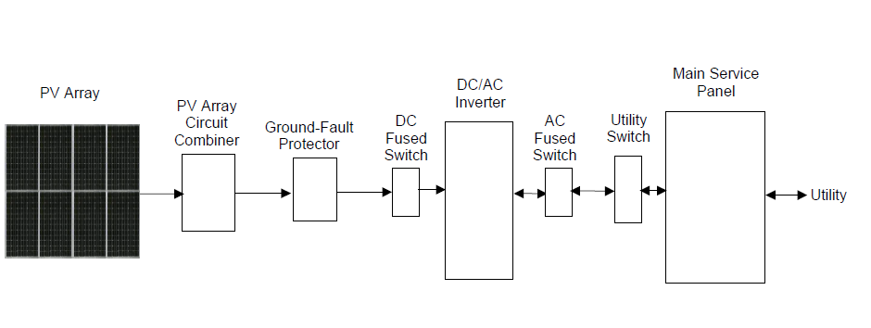

**Figure 1 Basic hybrid PV System Overview**

**Equipment Recommends:**

1. Materials should be designed to withstand the temperatures to which they are exposed.
2. All electrical equipment should be listed for the voltage and current ratings necessary for the application.
3. All exposed cables or conduits should be sunlight resistant.
4. All required overcurrent protection should be included in the system and should be accessible for maintenance.
5. All mounting equipment should be installed according to manufacturers’ specifications
6. All cables, conduit, exposed conductors and electrical boxes should be secured and supported according to code requirements.

**http://www.energy.ca.gov/reports/2001-09-04_500-01-020.PDF**

**Installation**

1. **PV Module (DC) Connection**

**CAUTION:** Before connecting to PV modules, please install separately a DC circuit breaker between inverter and PV modules.

Step 1: Check the input voltage of PV array modules.

Step 2: Disconnect the circuit breaker.

Step 3: Check correct polarity of connection cable from PV modules and PV input connectors. Then, connect positive pole (+) of connection cable to positive pole (+) of PV input connector. Connect negative pole (-) of connection cable to negative pole (-) of PV input connector.

Step 4: Make sure the wires are securely connected.

1. **Battery Connection**

**CAUTION:** Before connecting to batteries, please install separately a DC circuit breaker between inverter and batteries.

Step 1: Check the nominal voltage of batteries.

Step 2: Make sure the wires are securely connected

1. **Load (AC Output) Connection**

**CAUTION:** It's very important for system safety and efficient operation to use appropriate cable for AC connection.

1. **INVERTER STARTUP TESTS (hard hat, gloves, and eye protection recommended)**

* Be sure that the inverter is off before proceeding with this section.
* Test the continuity of all DC fuses to be installed in the DC string combiner box, install all string fuses, and close fused switches in combiner box.
* Check open circuit voltage at DC disconnect switch to ensure it is within proper limits according to the manufacturer’s installation manual.
* If installation contains additional DC disconnect switches repeat the step 4 voltage check on each switch working from the PV array to the inverter DC disconnect switch closing each switch after the test is made except for the final switch before the inverter (it is possible that the system only has a single DC switch).
* At this point consult the inverter manual and follow proper startup procedure (all power to the inverter should be off at this time).
* Confirm that the inverter is operating and record the DC operating voltage in the following space.
* Confirm that the operating voltage is within proper limits according to the manufacturer’s installation manual.
* After recording the operating voltage at the inverter close any open boxes related to the inverter system.
* Confirm that the inverter is producing the expected power output on the supplied meter.
* Provide the homeowner with the initial startup test report.

**SHUTDOWN SYSTEM (For maintenance)**

1. Turn off the main DC battery isolator;
2. Turn off the Solar Array AC Main Switch located in the switchboard or next to the inverter;
3. Turn off the Solar Array DC Main Switch located next to the inverter.
4. Please also check the shutdown procedure on the main switchboard.

**Maintenance & Cleaning**

Check the following points to ensure proper operation of whole solar system at regular intervals.

* Ensure all connectors are cleaned all the time.
* Before cleaning, be sure to turn off all the breakers (AC breaker, battery breaker and PV DC breaker).
* Clean during the cool time of the day, whenever it is visibly dirty.
* Periodically inspect the system to make sure that all wires and supports are securely fastened in place.

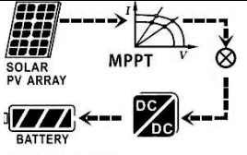

**TO RESTART THE SYSTEM**

1. Turn on the Solar Array DC Main Switch located next to the inverter.
2. Turn on Solar Array AC Main Switch located in the switchboard and/or next to the inverter.

3. Turn on the main DC battery isolator

**REF:**

[**http://www.voltronicpower.com/oCart2/files/manual/InfiniSolar-2KW3KW-manual-20150310.pdf**](http://www.voltronicpower.com/oCart2/files/manual/InfiniSolar-2KW3KW-manual-20150310.pdf)

<http://www.bradfordsolar.com.au/~/media/bradford-solar/files/pdfs/solar-owners-handover/maintenance-log--solar-owners-handover.pdf>